**IT24102400**

**Amarasinghe.A.Y.U. A**

**Lab Sheet 10**

**Exercise**

01)

i)

Null Hypothesis (H₀): All four snack types are equally likely to be chosen by customers.  
That is, P(A) = P(B) = P(C) = P(D) = 0.25.

Alternative Hypothesis (H₁): The probabilities of choosing the snack types are not all equal at least one snack type has a probability different from 0.25.

ii)

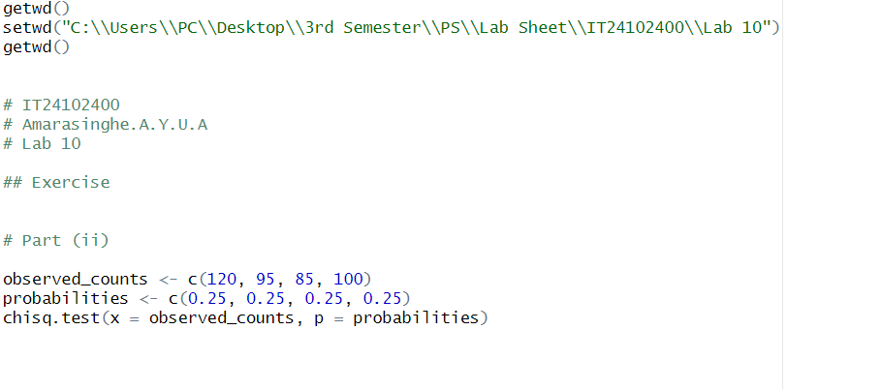

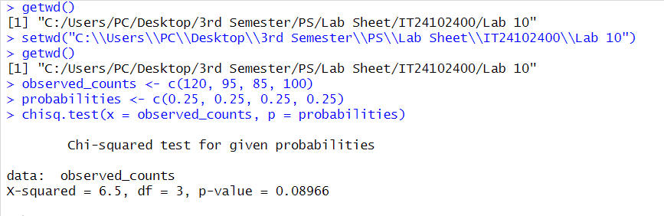

iii)

* Significance Level: 5%
* Rejection Rule: Reject the null hypothesis if the p-value is less than 0.05.
* P-value: The calculated p-value is 0.08966.
* Decision: Since the p-value (0.08966) is greater than 0.05, we fail to reject the null hypothesis.

**Conclusion:** The results provide enough evidence to state that customers select all four snack types equally. Therefore, the vending machine owner's claim is supported by the data.